Project Design Phase-II
Technology Stack (Architecture & Stack)
Date | 10 July 2026
Team ID | [Your Team ID]
Project Name | House Rent — Broker-Mediated Real Estate Platform
Maximum Marks | 4 Marks
Technical Architecture:
The deliverable below includes the technology-stack flow diagram, followed by Table 1 (Components & Technologies) and Table 2 (Application Characteristics).
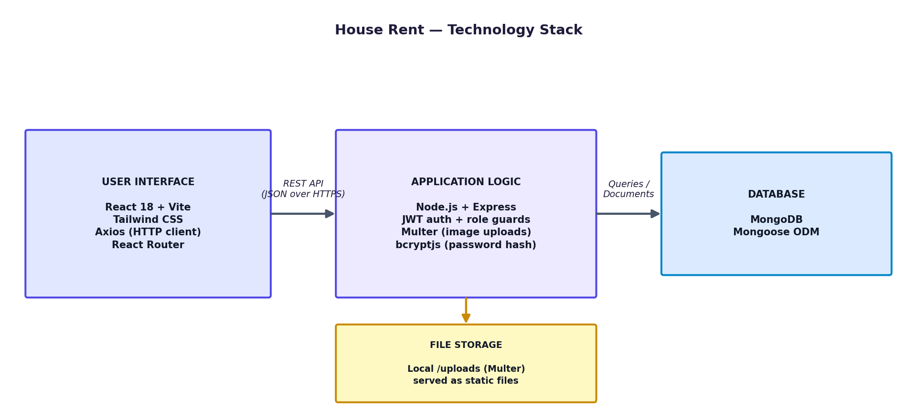
Figure: House Rent — Technology Stack flow
Table-1: Components & Technologies:
S.No. | Component | Description | Technology
1. | User Interface | How the user interacts with the application — web UI (dashboards for Owner/Renter/Admin, property browse & details pages) | HTML, CSS, JavaScript, React 18 (Vite), Tailwind CSS, React Router
2. | Application Logic-1 | Authentication & authorization — registration, login, role selection, JWT issuance and verification | Node.js, Express, jsonwebtoken, bcryptjs
3. | Application Logic-2 | Property listing lifecycle — create/edit/delete, availability toggle, admin approve/reject workflow | Node.js, Express, Mongoose
4. | Application Logic-3 | Booking / enquiry management — create booking, status transitions (pending/booked/cancelled) | Node.js, Express, Mongoose
5. | Database | Data type, configuration — Users, Properties, Bookings collections with ObjectId references between them | MongoDB (NoSQL), Mongoose ODM
6. | Cloud Database | Database service on cloud for production deployments | MongoDB Atlas
7. | File Storage | Property image uploads, stored on disk and served as static files | Multer + local filesystem (server/uploads)
8. | External API-1 | None required for the core workflow (kept dependency-free by design) | —
9. | External API-2 | Planned: free geocoding for the map-view enhancement | OpenStreetMap Nominatim (planned)
10. | Machine Learning Model | Not used in the current scope | —
11. | Infrastructure (Server / Cloud) | Application deployment on local system during development; cloud hosting for production | Local: Node.js + MongoDB Community  Cloud: Render/Railway (API) + MongoDB Atlas (DB) + Vercel/Netlify (frontend), or similar
Table-2: Application Characteristics:
S.No. | Characteristics | Description | Technology
1. | Open-Source Frameworks | React, Express, Mongoose, Tailwind CSS — all core frameworks used are open-source | React 18, Express 4, Mongoose 8, Tailwind CSS 3
2. | Security Implementations | Password hashing, JWT auth, server-side role checks, admin self-registration blocked at the API layer | bcryptjs (hashing), JWT (jsonwebtoken), custom requireAuth/requireRole middleware
3. | Scalable Architecture | Stateless 3-tier architecture (Client / API / Database); no server-side session state, so the API layer can scale horizontally | Express REST API + MongoDB
4. | Availability | Stateless JWT auth means any API instance can serve any authenticated request; MongoDB Atlas offers replica-set failover in production | JWT (client-held session) + MongoDB Atlas replica set
5. | Performance | Filtered MongoDB queries (status/owner/tenant/price-range indexes) avoid over-fetching; images served as static files rather than through the API | MongoDB indexes, static file serving via Express
References:
https://c4model.com/
https://www.mongodb.com/docs/atlas/
https://expressjs.com/
https://react.dev/

